# Brainstorm

**TIP**

You can select a sticky note and hit the pencil [switch to sketch] icon to start drawing!

### Before you collaborate

A little bit of preparation goes a long way with this session. Here’s what you need to do to get going.

**10 minutes**

### 1

**Define your problem statement**

What problem are you trying to solve? Frame your problem as a How Might We statement. This will be the focus of your brainstorm.

**5 minutes**

### 2

**Brainstorm**

Write down any ideas that come to mind that address your problem statement.

**10 minutes**

**3**

### Group ideas

Take turns sharing your ideas while clustering similar or related notes as you go. In the last 10 minutes, give each cluster a sentence-like label. If a cluster is bigger than six sticky notes, try and see if you and break it up into smaller sub-groups.

**20 minutes**

### 4

**Prioritize**

Your team should all be on the same page about what's important moving forward. Place your ideas on this grid to determine which ideas are important and which are feasible.

**20 minutes**

### After you collaborate

You can export the mural as an image or pdf to share with members of your company who might find it helpful.

**Quick add-ons**

# & idea prioritization

**A Team gathering**

Define who should participate in the session and send an

**DIGITALIZE FARM**

**JOTHIKA K**

**OVIYA VS**

**PRABHAKARAN S**

**SEENIVASAN G**

1. **Share the mural**

**DRONE SYSTEM**

**SMART SENSORS**

invite. Share relevant information or pre-work ahead.

**SELF DRIVING VEHICLES**

**DIGITAIZE**

**PROBLEM**

**How might we [your problem statement]?**

**DRONES**

**SMART**

**WILD ANIMAL**

**AGRICULTURAL**

**NATURAL**

**TELEMATICS POSITINING**

**HARDWARE AND**

**SOFTWARE**

**IOT AND**

**HUMIDITY**

**Share a view link** to the mural with stakeholders to keep

## Use this template in your own

1. **Set the goal**

**TIP**

Add customizable tags to sticky notes to make it easier to find, browse, organize, and categorize important ideas as themes within your mural.

**FARM**

**AUTOMATIC**

**COLLARS**

**PROTECTION**

**BIOPHYSICAL**

**FENCES**

**ELECTRONIC**

**REPELLENTS**

**TECHNOLOGIES**

**SOFTWARE**

**SPRINKLER**

**APPLICATIONS COMMUNICATION**

**ANTI -INSECT**

**ANTI BIRD**

them in the loop about the outcomes of the session.

## brainstorming sessions so your team

can unleash their imagination and start shaping concepts even if you're not sitting in the same room.

Think about the problem you'll be focusing on solving in the brainstorming session.

1. **Learn how to use the facilitation tools**

Use the Facilitation Superpowers to run a happy and

**SYSTEMS**

**SMART SENSORS**

**BARRIERS**

**REPELLENTS**

**USE AGRIVI**

**CLIMATE**

**SOIL FACTORS**

**SYSTEM**

**NETS**

**HAIL**

**MESH**

**PEST CONTROL**

**SOIL POLUTION**

**CLIMATE CHANGES**

**RELIABLE WATER COTROL SYSTEMS**

**CLIMATE**

**B Export the mural**

Export a copy of the mural as a PNG or PDF to attach to emails, include in slides, or save in your drive.

**10 minutes** to prepare

**1 hour** to collaborate

**2-8 people** recommended

productive session.

[**Open article**](https://support.mural.co/en/articles/2113740-facilitation-superpowers)

### Key rules of brainstorming

**SPRINKLE SYSTEMS**

**AGRICULTURE FENCES**

To run an smooth and productive session

**INCREASED WORK EFFICIENCY**

**INCREASED**

**YIELDS INCREASED**

**PROTECTIONS**

**SELF DRIVING VEHICLE**

**SOFTWARE APPLICATION**

### Keep moving forward

**Strategy blueprint**

Define the components of a new idea or strategy.

[**Open the template**](https://app.mural.co/template/e95f612a-f72a-4772-bc48-545aaa04e0c9/984865a6-0a96-4472-a48d-47639307b3ca)

**Customer experience journey map**

Understand customer needs, motivations, and

Stay in topic. Defer judgment.

Encourage wild ideas. Listen to others.

**REMOTE MONITORING**

**LOWERED OPERATION**

**IMPROVE PRODUCTIVITY**

### Importance

If each of these

**ANTI BIRD**

obstacles for an experience.

[**Open the template**](https://app.mural.co/template/b7114010-3a67-4d63-a51d-6f2cedc9633f/c1b465ab-57af-4624-8faf-ebb312edc0eb)

**USE AGRIVI**

Go for volume. If possible, be visual.

**COST**

tasks could get

done without any difficulty or cost, which would have the most positive impact?

**MESH**

**Strengths, weaknesses, opportunities & threats**

Identify strengths, weaknesses, opportunities, and threats (SWOT) to develop a plan.

**SOIL MANAGEMENT**

|  |  |
| --- | --- |
|  |  |
|  |  |

[**Open the template**](https://app.mural.co/template/6a062671-89ee-4b76-9409-2603d8b098be/ca270343-1d54-4952-9d8c-fbc303ffd0f2)

**TIP**

Participants can use their cursors to point at where sticky notes should go on the grid. The facilitator can confirm the spot by using the laser pointer holding the **H key** on the keyboard.

**SMART SENSOR**

**HUMIDITY**

**LIGHT AND HEAT CONTROL**

[**Share template feedback**](https://muralco.typeform.com/to/CiqaHVat?typeform-source=app.mural.co)

[**Share template feedback**](https://muralco.typeform.com/to/CiqaHVat?typeform-source=app.mural.co)

### Feasibility

Regardless of their importance, which tasks are more feasible than others? (Cost, time, effort, complexity, etc.)

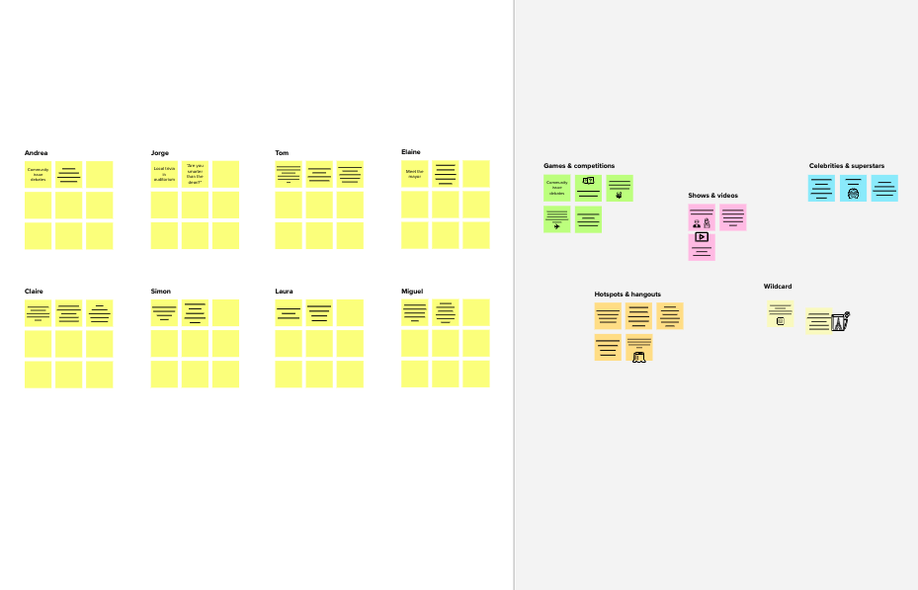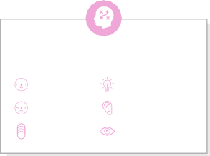

**Template**

**Need some inspiration?**

See a finished version of this template to kickstart your work.

[**Open example**](https://app.mural.co/template/e5a93b7b-49f2-48c9-afd7-a635d860eba6/93f1b98d-b2d2-4695-8e85-7e9c0d2fd9b9)

|  |  |  |  |  |
| --- | --- | --- | --- | --- |
|  |  |  |  |  |
|  |  |  |  |  |